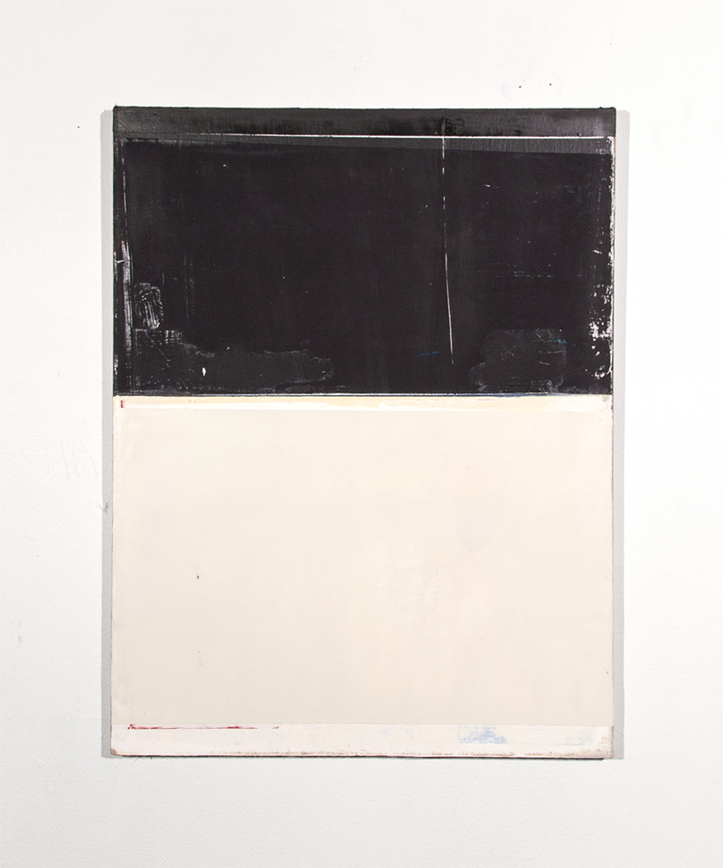

Half Life, 2014

Oil on linen

17 ¾ x 13 ¾ inches

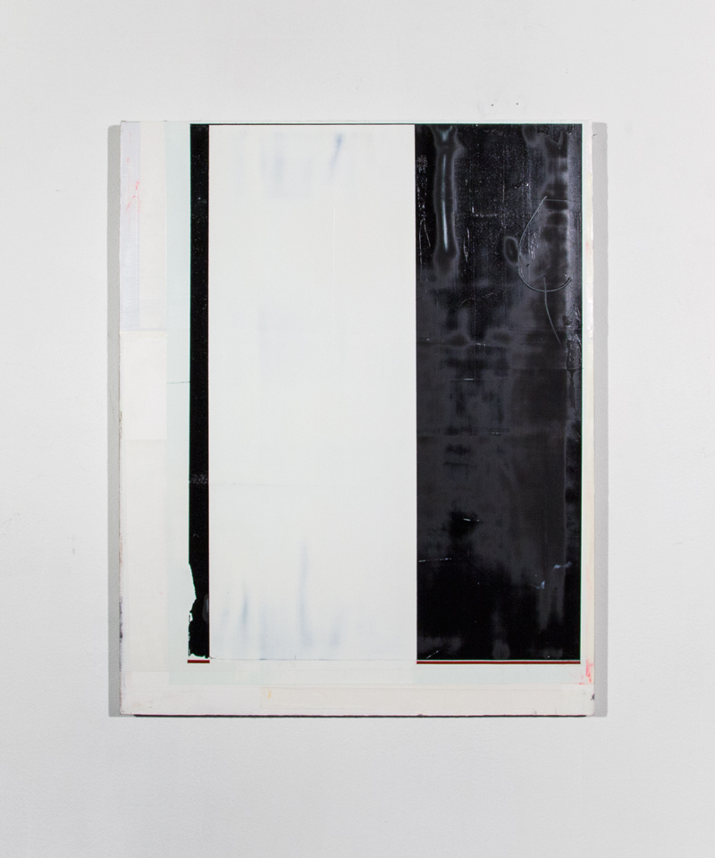

N. lo, 2014

Oil on linen

19 ¾ x 15 ¾ inches

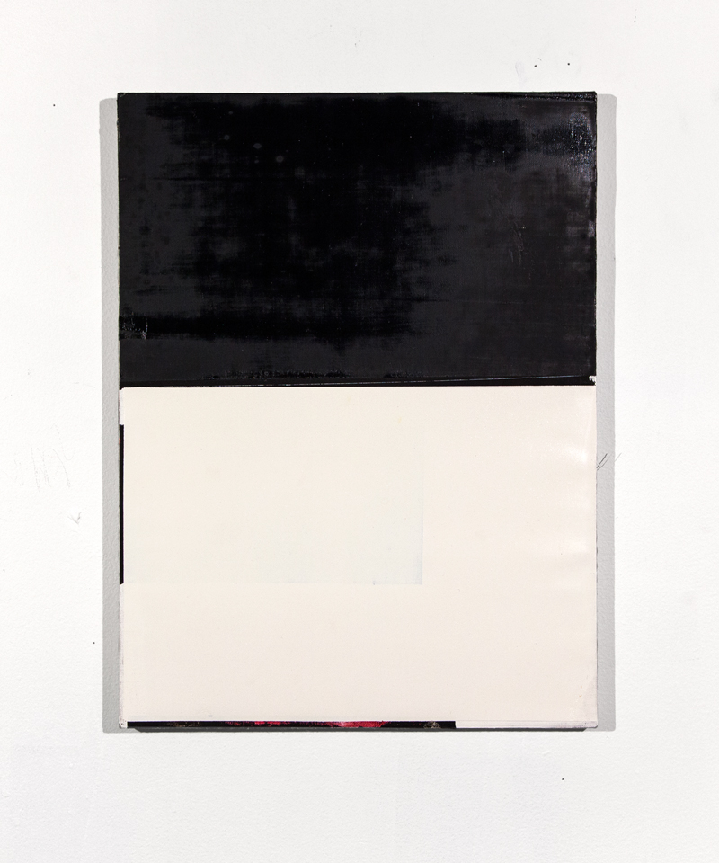

Black White, 2014

Oil on linen

16 x 12 inches

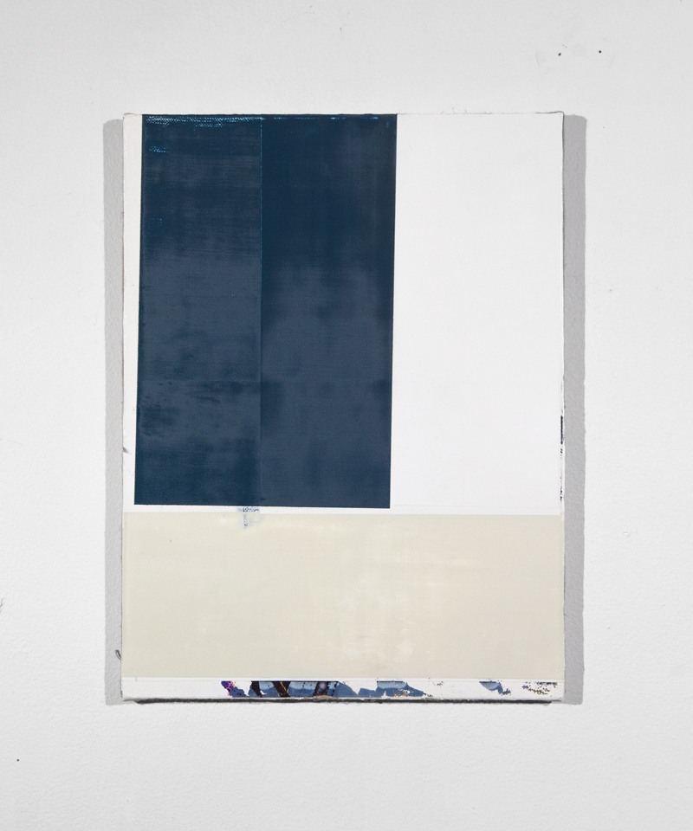

Chinese Water, 2015

Oil on linen

12 x9 1/8 inches

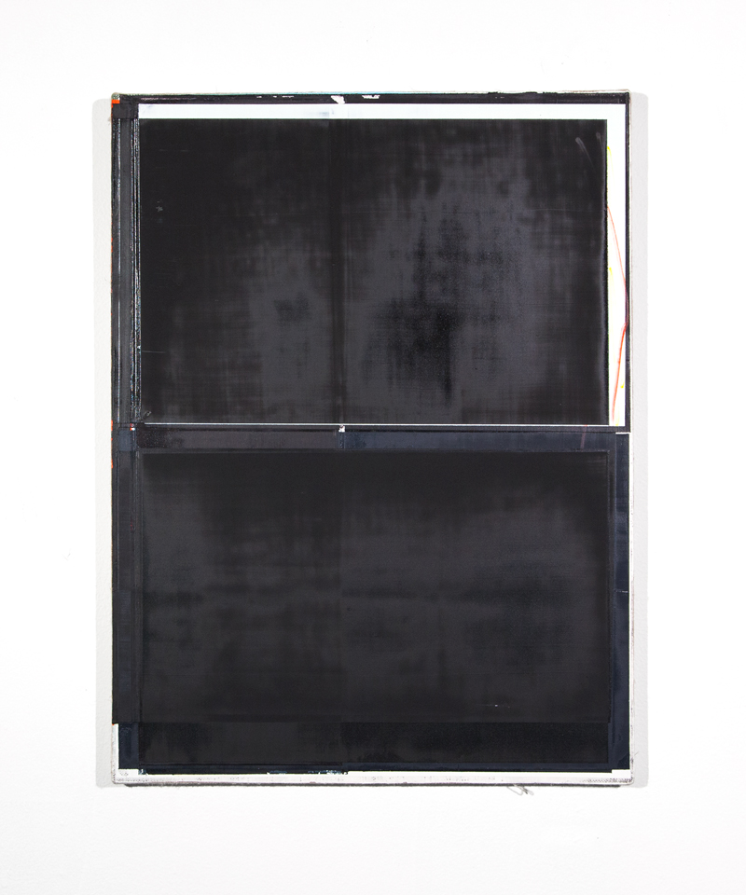

Hard Times, 2015

Oil on linen

16 x 12 inches

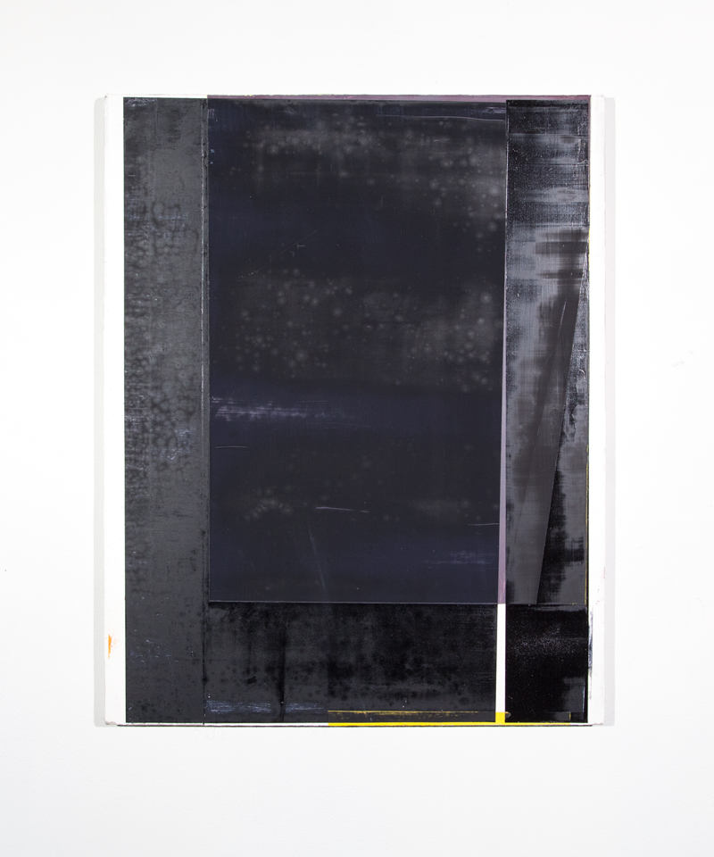

Purple 1, 2014

Oil on linen

20 x 16 inches

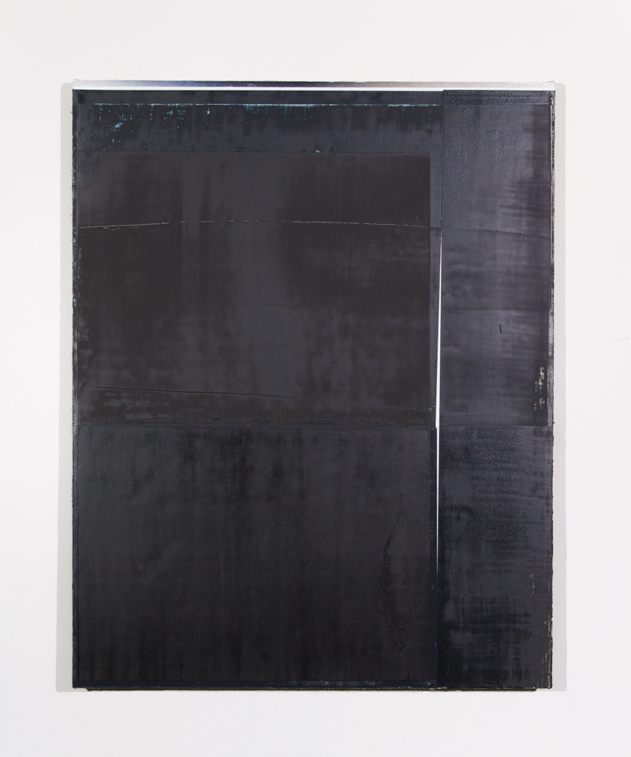

NO TITLE

Oil on linen

20 ¾ x 16 inches

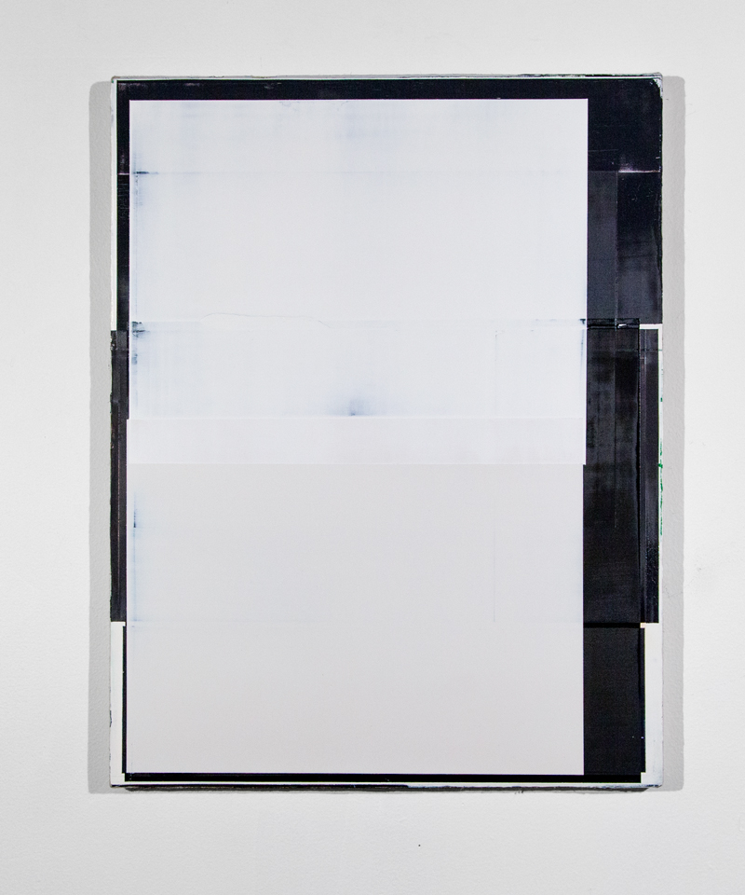

20145, 2015

Oil on linen

18 x 14 1/8 inches

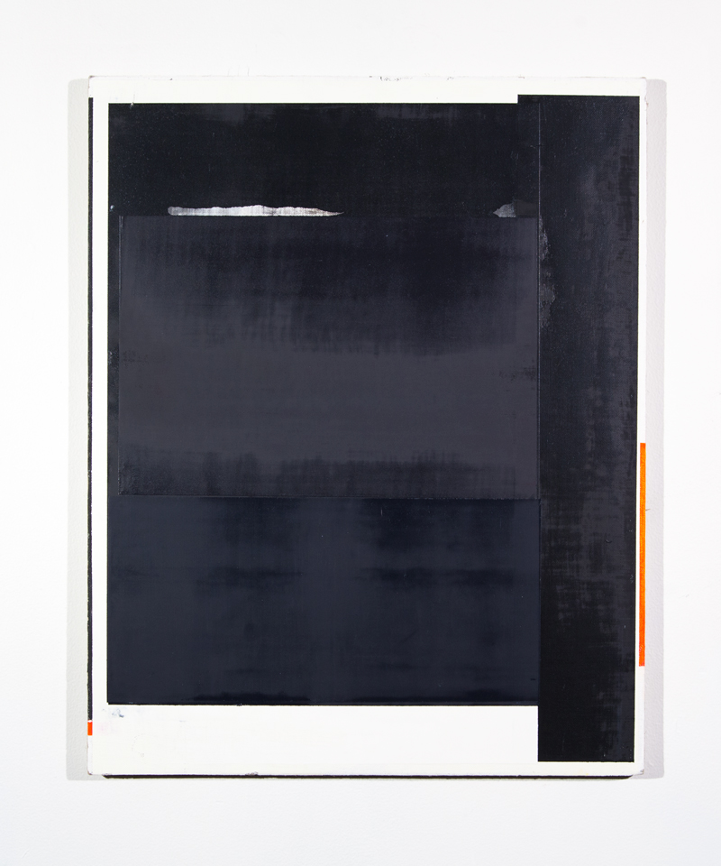

Seven Nine, 2015

Oil on linen

20 x 16 inches

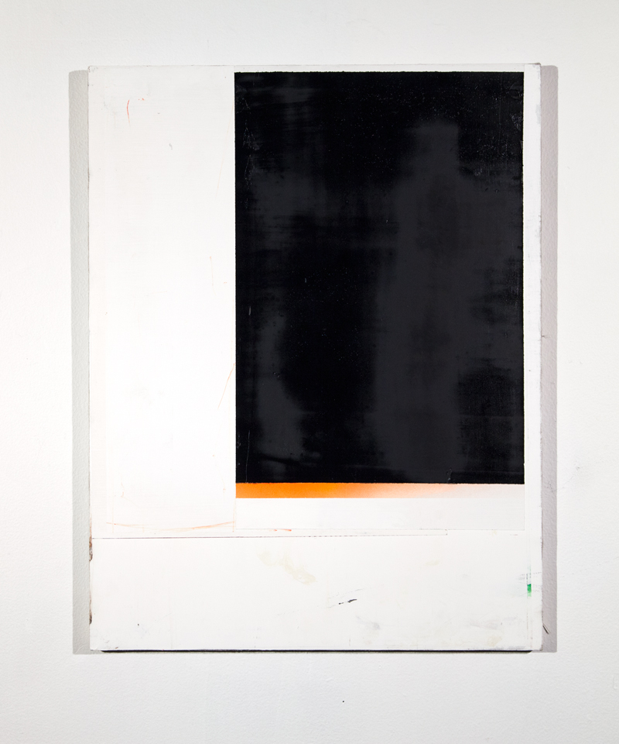

Untitled 2, 2014

17 ¾ x 13 ¾ inches

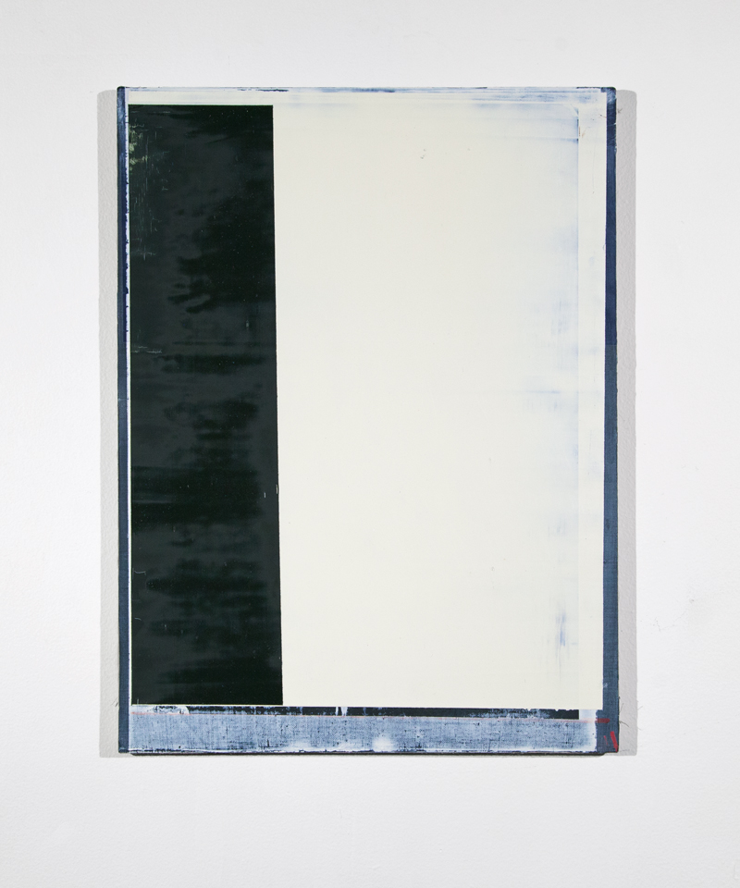

Untitled 4, 2014

Oil on linen

16 x 12 inches

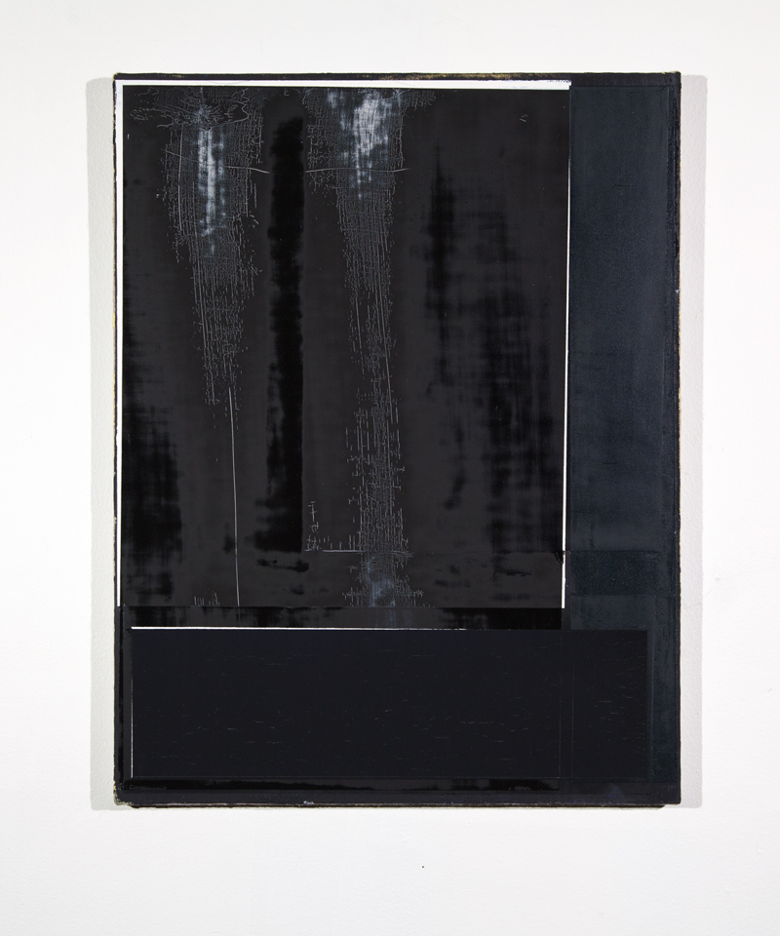

Untitled 5, 2014

Oil on linen

17 3/4 x 13 3/4 inches

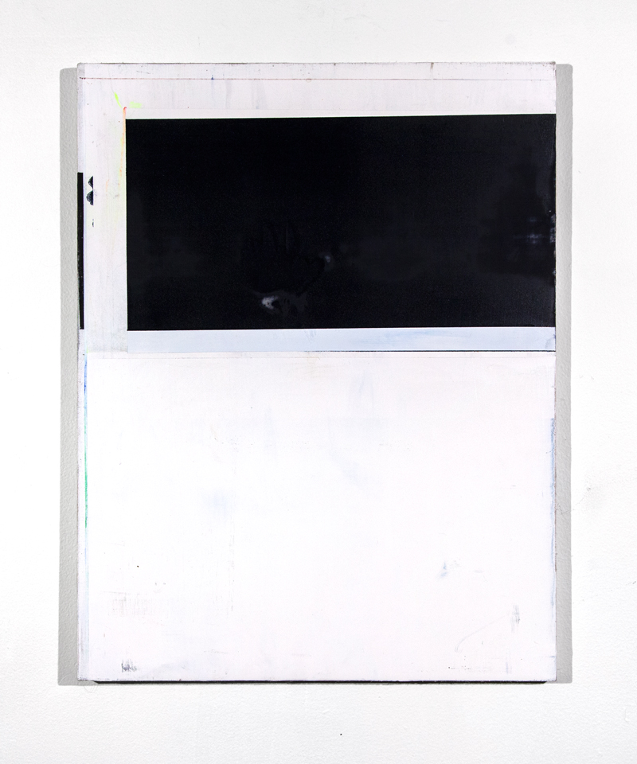

Untitled 3, 2014

17 ¾ x 13 ¾ inches

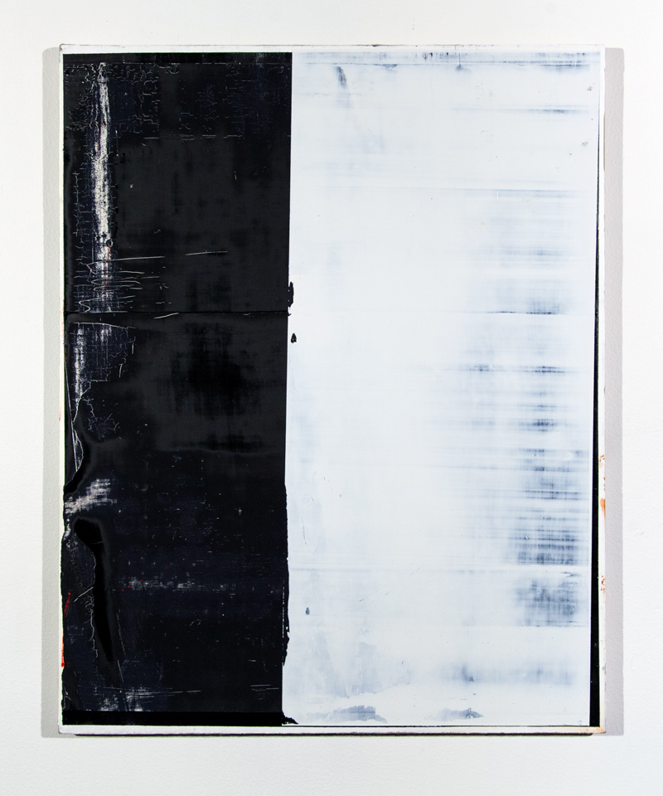

Scarface, 2014

Oil on linen

20 1/8 x 16 inches

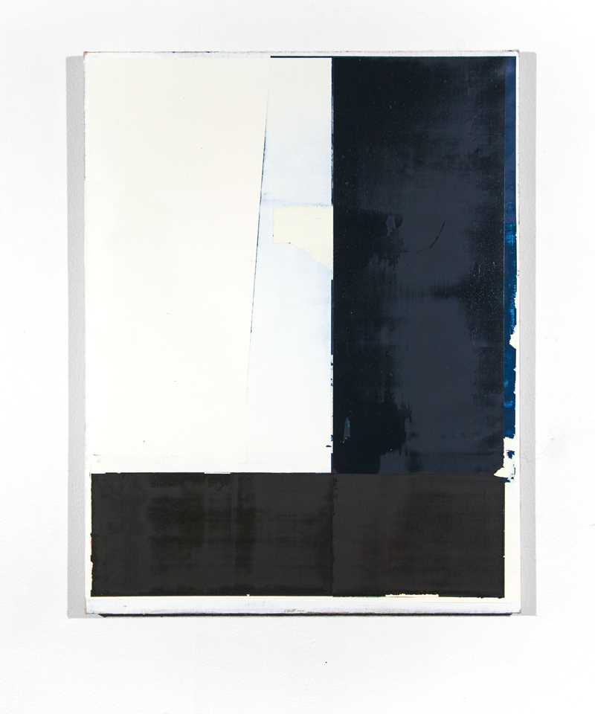

Untitled 6, 2015

Oil on linen

17 ¾ 13 ¾ inches

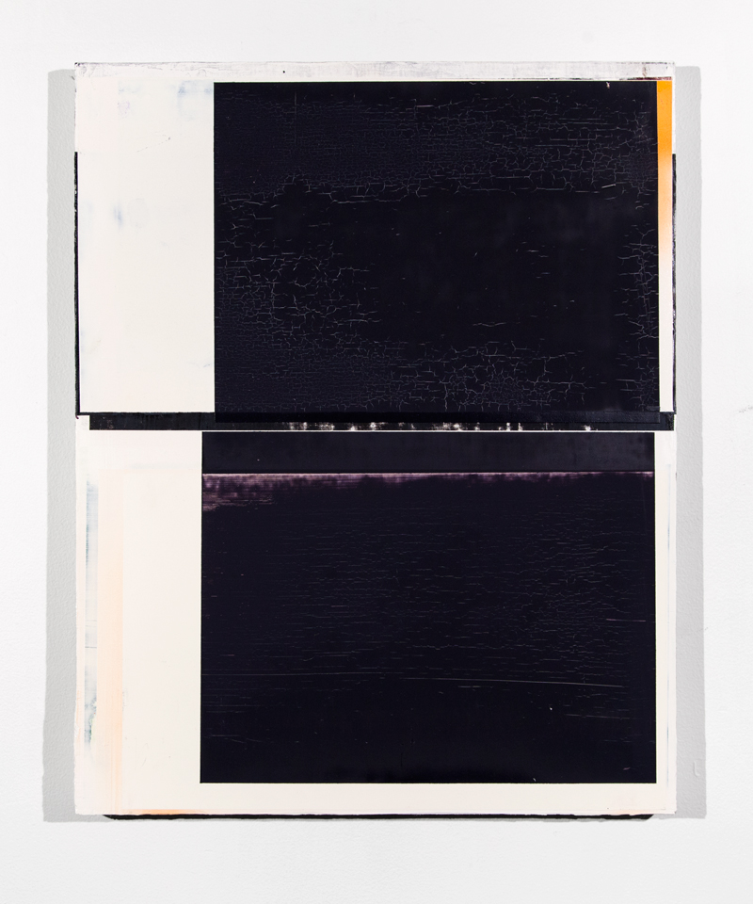

The Hills Have Eyes, 2014

Oil on linen

20 x 16 inches

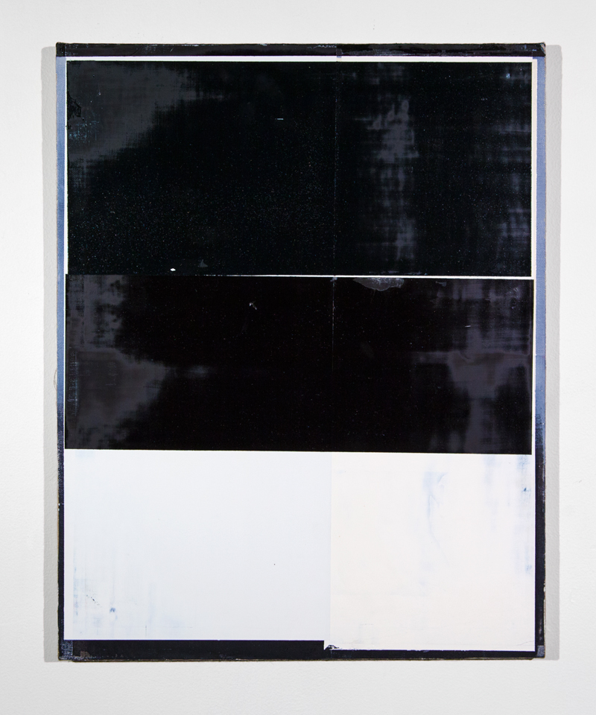

Trust, 2015

Oil on linen

15 7/8 x 20 inches

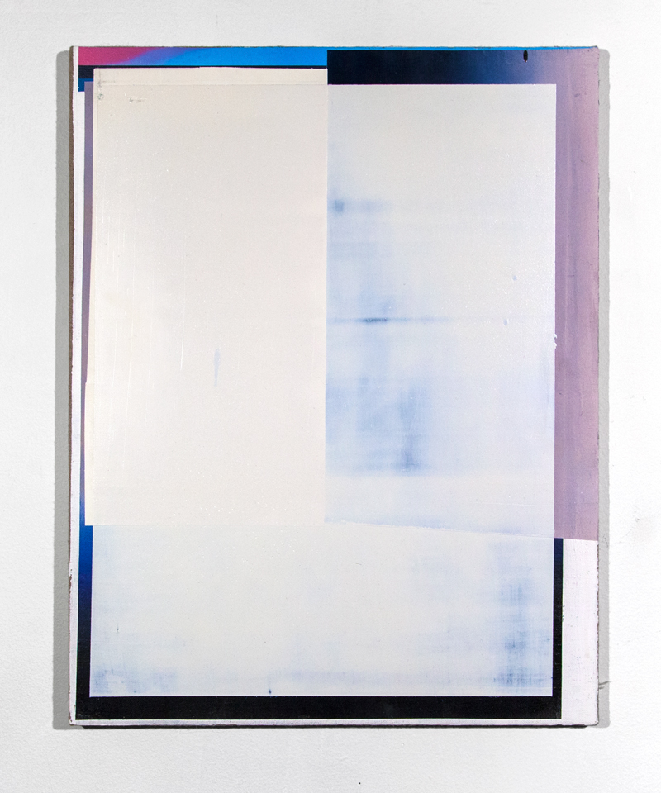

Untitled, 2014

Oil on linen

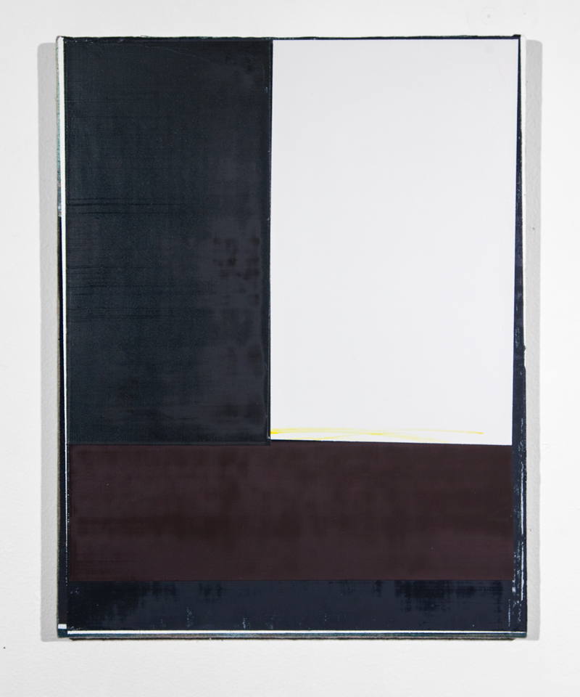

Juicyfruit, 2015

Oil on linen

13 3/4 x 10 3/4 inches

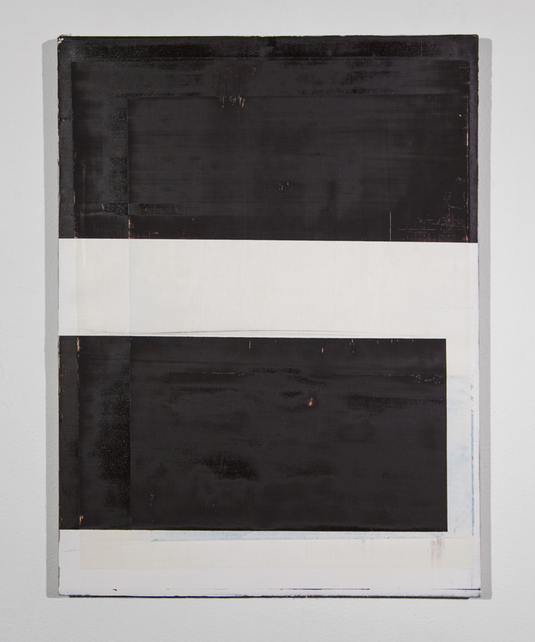

Untitled 1, 2014

Oil on linen

16 x 12 inches

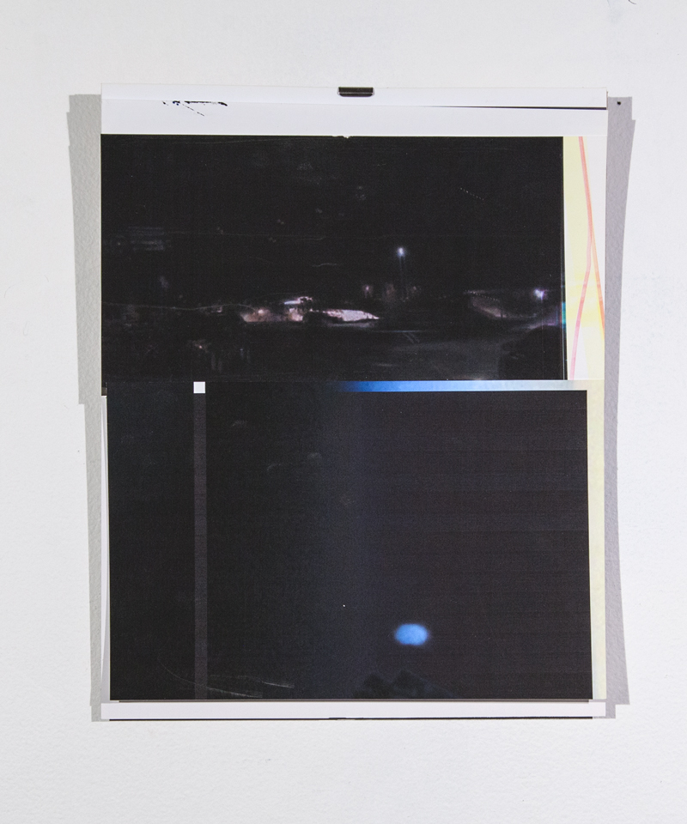

Collage 3, 2014

Photo paper

10 x 8 inches

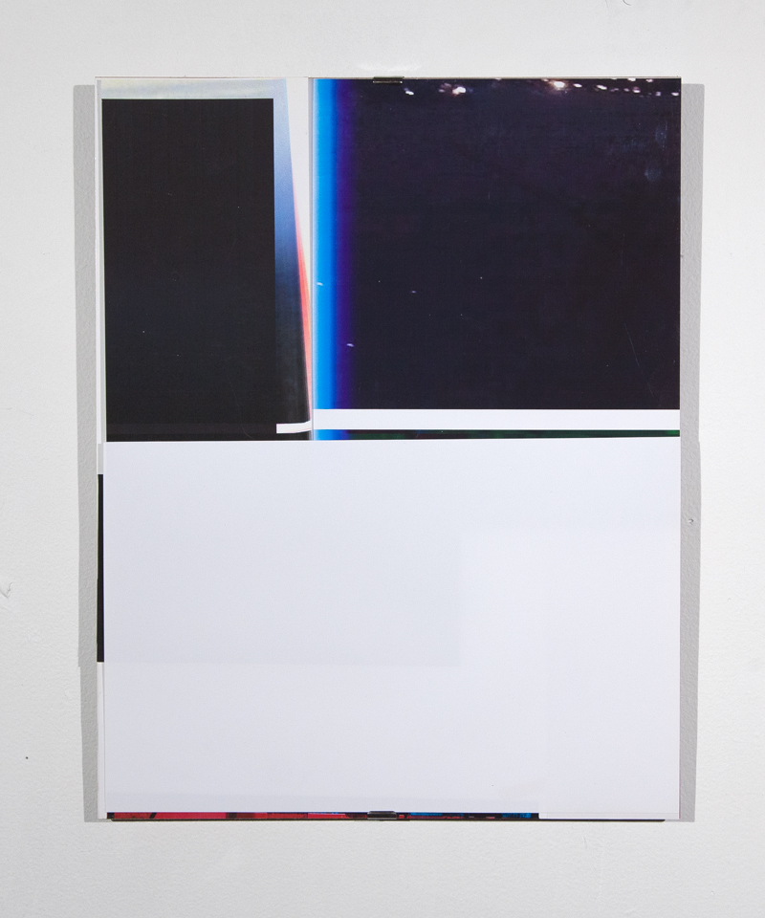

Collage 2, 2014

Photo paper

14 x 11 inches

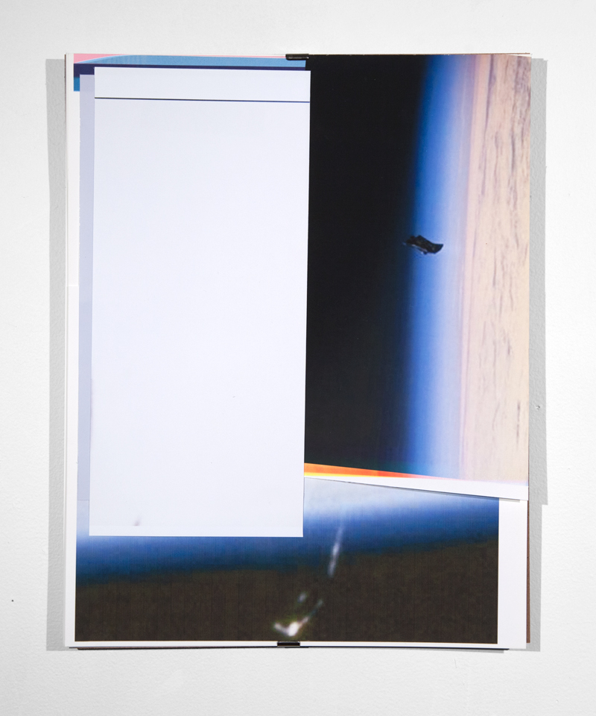

Collage 4, 2014

Photo paper

14 x 11 inches

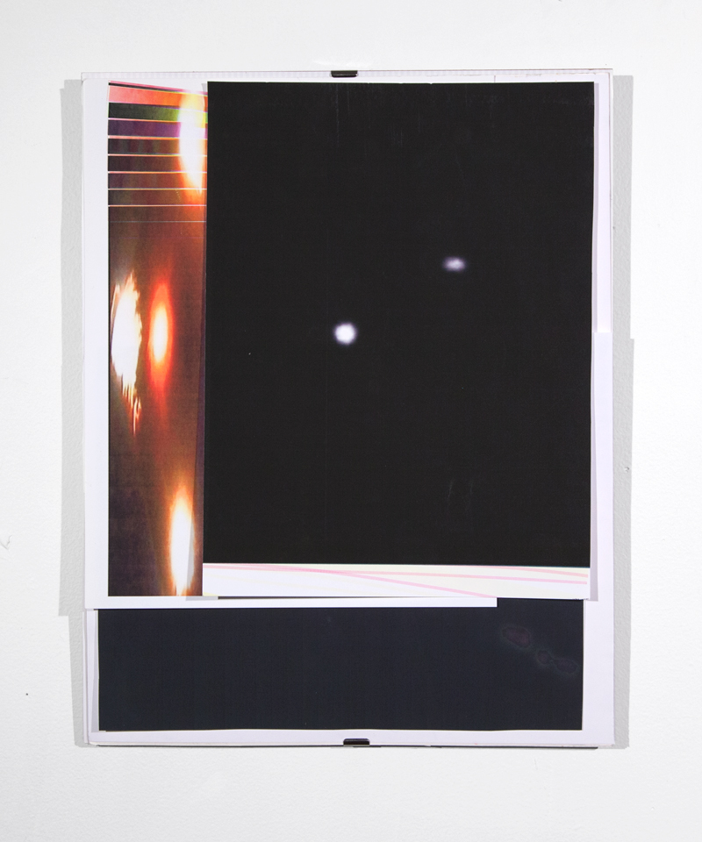

Collage 1, 2014

Photo paper

14 x 11 inches

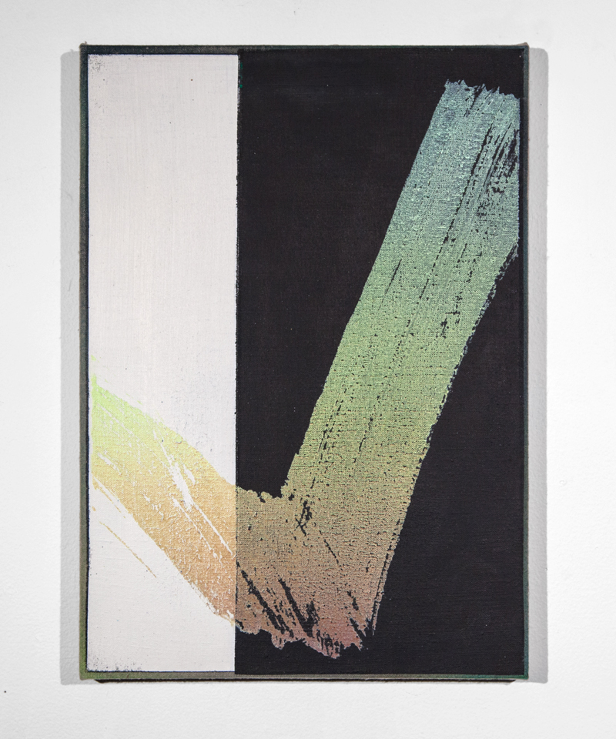

Untitled, 2013

Oil on linen

9 7/8 x 13 7/8 inches